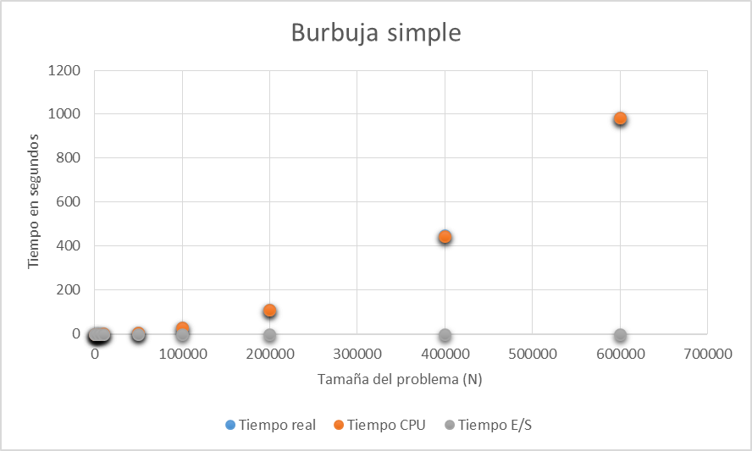

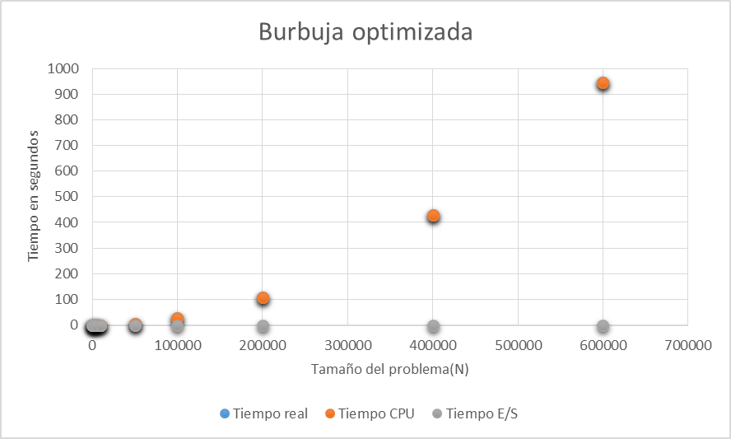

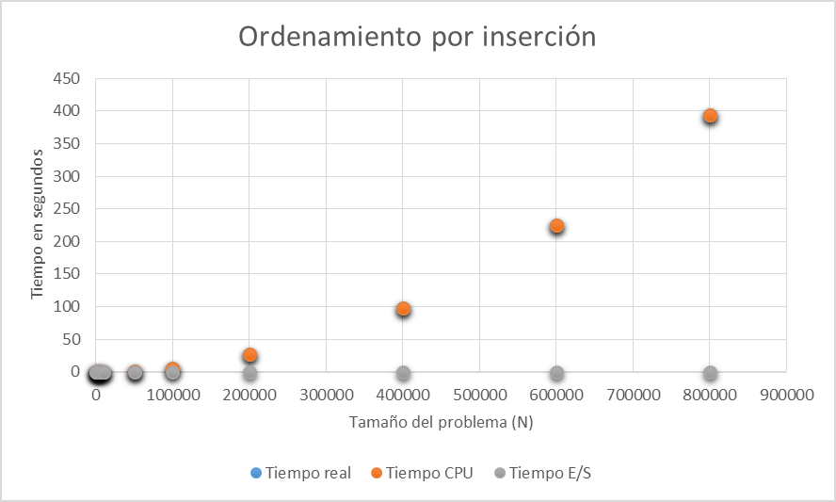

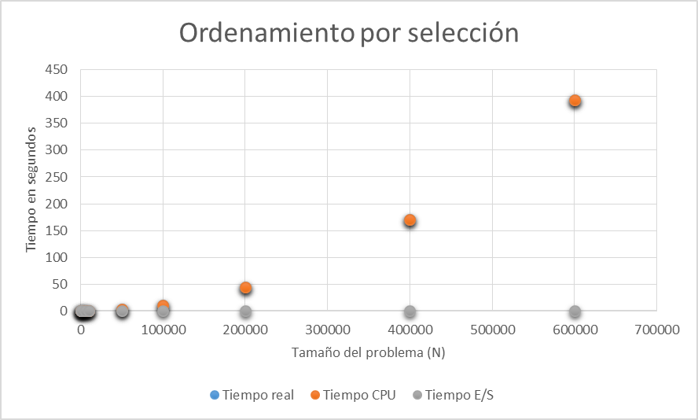

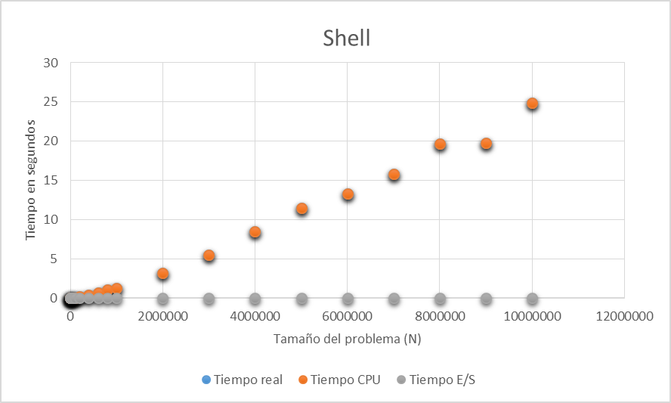

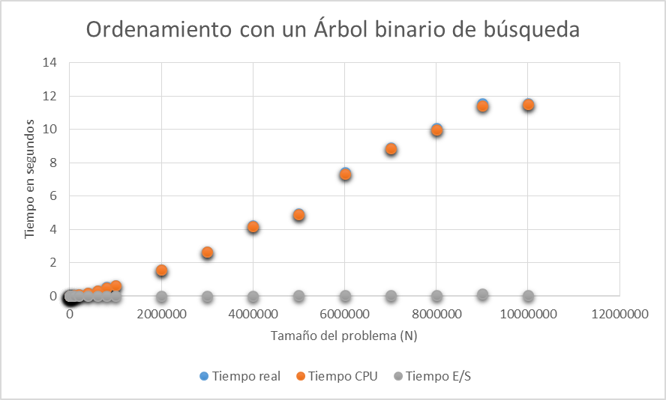

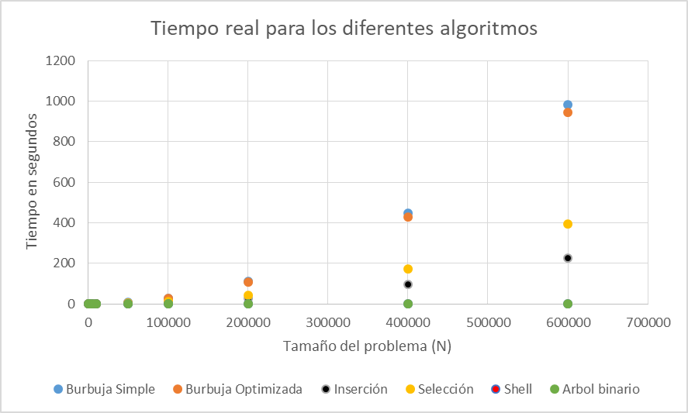

Burbuja simple:

N=1

1.519527452015423e-03 x - 55.5794

N=2

2.674812512303883e-09 x2 + 3.878102482045647e-05 x - 1.0038

N=3

-4.556540957464123e-16 x3 + 3.068260930536768e-09 x2 - 3.804021234261248e-05 x + 0.2616

N=4

-9.789651168578290e-22 x4 + 6.502980944869945e-16 x3 + 2.700680047239788e-09 x2 - 3.847341670980356e-06 x -0.0027

N=8

-2.12766813740185e-40 x8 + 2.90802435291546e-34 x7 - 1.37842222072597e-28 x6 + 2.78234703523473e-23 x5 - 2.45628634646540e-18 x4 + 8.99719529233187e-14 x3 + 1.54361647048513e-09 x2 + 1.07143550787699e-06 x - 9.85876467786142e-05

Burbuja optimizada:

N=1

0.00146107454749725 x - 53.3890

N=2

2.57238614542577e-09 x2 + 3.70302166576954e-05 x - 0.9033

N=3

-3.65584879519962e-16 x3 + 2.88806155341560e-09 x2 - 2.46057545647931e-05 + 0.1119

N=4

-1.46590636433398e-22 x4 - 1.99979146854441e-16 x3 + 2.83301984182101e-09 x2 - 1.94857001451546e-05 x + 0.0723656904176590

N=8

-1.42039654437986e-40 x8 + 1.93394267315673e-34 x7 - 9.09852541878559e-29 x6 + 1.80694523858545e-23 x5 - 1.53617410922537e-18 x4 + 5.15883706335045e-14 x3 + 2.04939414024803e-09 x2 - 3.78720484839896e-07 x + 3.92621592414839e-05

Inserción

N=1

0.000447131277926480 x - 21.6850

N=2

6.06112107755850e-10 x2 + 8.12838295127691e-06 x - 0.0913

N=3

-2.17174305938586e-17 x3 + 6.31351564517502e-10 x2 + 1.32741326008042e-06 x + 0.0611

N=4

-3.99436916387043e-22 x4 + 5.91262163603944e-16 x3 + 3.50569313728177e-10 x2 + 3.82633106859991e-05 x - 0.3702

N=8

-4.05272935997384e-43 x8 + 7.61591715336753e-37 x7 - 4.78097812168175e-31 x6 + 1.08284590585810e-25 x5 - 3.82518584728370e-21 x4 - 6.48850712561805e-16 x3 + 6.50582134728221e-10 x2 + 2.58421024246413e-07 x - 0.1167

Selección

N=1

0.000603609685093194 x - 22.3614042325015

N=2

1.11382753018410e-09 x2 - 1.29928349880812e-05 x + 0.364605572560146

N=3

2.15548807887764e-16 x3+ 9.27705341648736e-10 x2 + 2.33477273936483e-05 x - 0.233975301320910

N=4

1.12767578716850e-21 x4 - 1.05840415041085e-15 x3 + 1.35112396482753e-09 x2 - 1.60392453249942e-05 x + 0.0704379495316086

N=8

9.19694168356404e-41 x8 - 1.25313300358198e-34 x7 + 5.90668670478977e-29 x6 - 1.17887906574298e-23 x5 + 1.01361759945001e-18 x4 - 3.40943347691645e-14 x3 + 1.39982064244229e-09 x2 - 6.43467051199520e-08 x + 8.44381638972885e-06

Shell

N=1

2.38905155086007e-06 x - 0.5161

N=2

5.42484102211795e-14 x2 + 1.92113155283617e-06 x - 0.2263

N=3

-8.03893837339493e-21 x3 + 1.68671544042433e-13 x2 + 1.53614986995103e-06 x - 0.1192

N=4

5.04740333657904e-27 x4 - 1.05703802947671e-19 x3 + 7.46076345063883e-13 x2 + 5.07108208356875e-07 x + 0.0543

N=8

1.68630608660661e-52 x8 - 6.16880127140382e-45 x7 + 9.03631009235164e-38 x6 - 6.76258818199406e-31 x5 + 2.73233154629809e-24 x4 - 5.80866099227392e-18 x3 + 6.07450711326964e-12 x2 - 9.53572024510682e-07 x + 0.0535

Árbol

N=1

1.23868836989332e-06 x - 0.2949

N=2

2.28323014645839e-14 x2 + 1.04174821233608e-06 x - 0.1728

N=3

-1.68406177636744e-20 x3 + 2.62535129189052e-13 x2 + 2.35257471103194e-07 x + 0.0514

N=4

-2.37552277394066e-27 x4 + 2.91246230817835e-20 x3 - 9.21613837237452e-15 x2 + 7.19568262106368e-07 x - 0.0303

N=8

-5.58635741189029e-53 x8 + 2.10681403254416e-45 x7 - 3.19009255543104e-38 x6 + 2.47263444820234e-31 x5 - 1.03560646854061e-24 x4 + 2.26241046069984e-18 x3 - 2.15123112344179e-12 x2 + 1.31625470894367e-06 x - 0.0306

